POWER BI REPORT

Financial Transactions
& Loans Dashboard

BY:D.MITHRA
B.COM (FINTECH WITH AI )
E25FA025

1. Introduction
Power BI is a business intelligence tool that turns data into clear charts, cards, and tables. It helps people understand information quickly instead of reading a large amount of raw data. For this report, I reviewed the uploaded Power BI project titled “Financial Transactions & Loans Dashboard.” The dashboard brings customer, account, loan, and transaction information together in one place.
The main purpose of this dashboard is to give a quick overview of financial activity and make it easier to explore transaction patterns. It can help a user see important totals first and then look more closely at the different transaction types.

2. Objectives of the Dashboard
- To show key information about customers, active accounts, and active loans.
- To display the overall value of transactions in a simple, easy-to-read format.
- To compare transaction activity across different categories or types.
- To present transaction information in charts and a summary table.
- To help users explore details and identify patterns that may need further attention.

3. Main Components

3.1 Summary cards
The dashboard includes cards for Total Customers, Active Accounts, Active Loans, and Total Transaction Value. These cards are useful because they place important indicators at the top of the report. A viewer can understand the overall situation quickly without checking every chart.

3.2 Charts and visualisations
The report includes column, line, donut, and bar chart visuals. Each chart can answer a different type of question. A column chart is useful for comparing categories, a line chart can show changes or trends, a donut chart shows how categories contribute to a whole, and a bar chart makes it easier to compare transaction types.

3.3 Transaction summary table
A table titled “Transaction Summary” brings together transaction type, total transaction value, and total transactions. This is useful when a reader needs more precise information than a chart alone can provide.

3.4 Drill-through and navigation
The project includes a Finance Overview page designed for drill-through, along with a back button. This supports moving from an overall view to a more focused view and returning to the previous page. Drill-through is helpful when a user wants to investigate a selected part of the data in more detail.

4. Key Performance Indicators (KPIs)
KPI | What it tells us | Why it is useful
Total Customers | The total number of customers represented in the data. | Helps understand the size of the customer base.
Active Accounts | The number of accounts marked as active. | Gives an overview of currently active accounts.
Active Loans | The number of loans marked as active. | Helps monitor the active loan portfolio.
Total Transaction Value | The combined value of transactions included in the report. | Shows the overall monetary scale of transaction activity.
Total Transactions | The number of transactions recorded for a category or in total, depending on the visual. | Helps compare transaction volume.

5. How the Visuals Help in Analysis
The cards provide a quick summary, while the charts help compare different parts of the data. For example, a bar or column chart can make it easier to notice which transaction type has a higher count or value. A line chart can help reveal a rise or fall across the categories or time periods used in the underlying data. A donut chart can show whether the total is concentrated in a few categories or spread more evenly.
The transaction table supports these visuals by showing the figures in a structured format. Using charts and a table together makes the dashboard easier to understand because users can see both the general pattern and the underlying values.
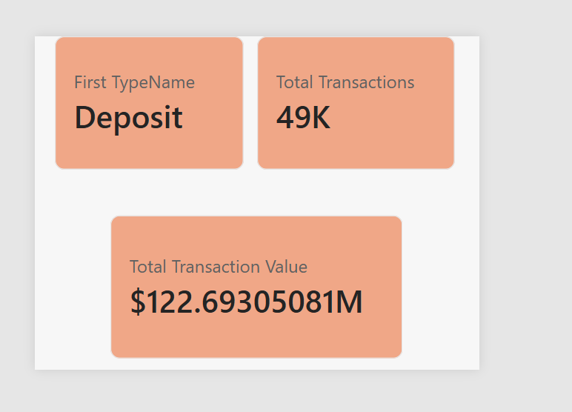
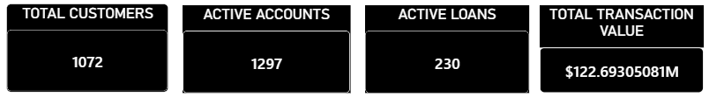

6. How to Use the Dashboard
- Start with the four summary cards to understand the overall customer, account, loan, and transaction picture.
- Review each chart to compare transaction activity and look for visible patterns.
- Use the transaction summary table to check the values for individual transaction types.
- If the report offers interactive filtering or drill-through for a selected item, use it to examine that area more closely.
- Return to the overview page after reviewing details so the overall picture remains clear.

7. Benefits
- Saves time by keeping several important indicators in one report.
- Makes financial information easier to understand through visual presentation.
- Supports comparison between transaction categories.
- Allows users to move from summary information to more detailed analysis.
- Can help managers or students ask better questions about customer activity, accounts, loans, and transactions.

8. Limitations and Points to Check
A dashboard is only as reliable as the data and calculations behind it. Before using the figures for an important decision, the user should confirm that the source data is complete, the measures are calculated correctly, and the reporting period is clear. The meaning of “active” should also be defined consistently for accounts and loans.
This report describes the layout and measures visible in the uploaded Power BI file. The exact KPI values have not been stated here because the project file’s underlying displayed results were not independently verified in this document. The figures should be copied from the dashboard after opening and refreshing it in Power BI Desktop.

9. Conclusion
Overall, the Financial Transactions & Loans Dashboard is designed to make financial information easier to review. The summary cards give a quick snapshot, the charts help users compare transaction activity, and the table provides a more detailed view of transaction types and totals. The drill-through navigation also supports further investigation. In my understanding, the main value of this dashboard is that it brings important information together and presents it in a way that is easier to read and discuss.
With accurate data and clearly defined KPIs, this type of Power BI dashboard can be a useful tool for learning financial analysis and monitoring financial activity.

